**Bird richness loss around motorways in fragmented agricultural landscape: a guild approach**

Hladík Štěpán a, ⁎, Zasadil Petr *b*, Barták Vojtěch c, Keken Zdeněk a

a *Department of Applied Ecology, Faculty of Environmental Sciences, Czech University of Life Sciences, Kamýcká 129, 165 00 Prague - Suchdol, Czech Republic*

*b Department of Ecology, Faculty of Environmental Sciences, Czech University of Life Sciences, Kamýcká 129, 165 00 Prague - Suchdol, Czech Republic*

*c Department of Spatial Sciences, Faculty of Environmental Sciences, Czech University of Life Sciences, Kamýcká 129, 165 00 Prague - Suchdol, Czech Republic*

*Keywords:*

⁎ Corresponding author.

*E-mail addresses:* hladiks@fzp.czu.cz (Š. Hladík)

**Abstract**

Road infrastructure is a significant factor that affects bird populations environment around the world. The pressure on birds that occurs in the surrounding environment of transport infrastructure is increased by road traffic. This study assesses the impact of motorways on the qualitative and quantitative characteristics of bird assemblages in agricultural landscape with scattered tree and shrub vegetation. The number of bird species was recorded at 298 observation points which involved four different distances approximately (25, 125, 500, and 1000 m) from the edge of motorway. Our findings indicate that motorway distance have a negative impact on bird richness. In direct relation to the motorway, the bird species richness is significantly decreasing. Results also show that woodland birds were influenced by the motorway distance similarly to farmland birds. We found also the negative impact of the motorway distance on insectivorous and granivorous species. Both of these food guilds increased with increasing distance from motorway, while granivorous species were affected more than insectivorous species. Furthermore, we noticed less impact of the motorway distance on nest guild species, while the most affected are shrub species. It is assumed that the main cause of the decrease in bird richness is noise, which is correlated with motorway distance and traffic volume. Farmland can facilitate the propagation of noise.

**1. Introduction**

The road traffic influences wildlife bird species in the surrounding habitats. Given that road traffic is projected to increase by 60% over 2010 by 2050, this impact is likely increase further. (Dulack, 2013). The greatest impact of road traffic on the surrounding landscape can be observed around high traffic motorways. Motorways directly affect nature, altering it, resulting in the displacement or destruction of natural habitats and physically changing the appearance of its immediate surroundings (Kušta et al., 2014, 2017; Keken et al., 2016, 2019; Bíl et al., 2016, 2019; 2020). Disturbance and isolation by transport disrupts or makes the migration of species impossible, reduces landscape connectivity and thus causes changes in the species distribution in the landscape. This barrier effect, which affects the ability of species to disperse, causes isolation and affects population dynamics (Forman & Alexander, 1998; Hlaváč & Anděl, 2001; Iuell et al., 2003). Further, presence of motorway in the landscape is associated with number of impacts such as lighting or chemical pollution, road mortality and probably the most frequently reported noise (Forman & Alexander, 1998; Coffin, 2007; Kociolek et al., 2011; Pinto et al., 2020). Significant role plays road mortality during breeding season and thus it can have population consequences (Pinto et al., 2020). Other negative effect associated with motorway traffic is that areas along it provide less suitable habitat quality (Johnson et al., 2022). Road traffic has an adverse impact on the environment, but not exclusively. Positive effect of roads on bird richness occurs in more anthropogenically modified landscapes (Kroeger et al., 2022). Motorways can provide foraging habitats and reduce the predation pressures. Motorway related infrastructure such as bridges, pylons and tree lines along roadside provide new nesting opportunities and protection against predators in an otherwise homogeneous landscape (Morelli et al., 2014). On the contrary, according to them negative effect is reported by studies in pure and untouched landscape (Kroeger et al., 2022). Birds that tolerate traffic are those that live in urban areas as road disturbances are similar to those they encounter there (Palomino & Carrascal, 2007; Cooke et al., 2020 b; Ascensão et al., 2022).

Most studies consider noise to be the most significant impact that motorways affect the surrounding landscape and bird species (Brumm, 2004; Slabbekoorn & Ripmeester, 2008; Halfwerk et al., 2011). The effect of traffic noise and other effects such as landscape fragmentation, define a road-effect zone with significantly alter environment (Forman & Alexander, 1998). Noise level is associated also with traffic volume. Nevertheless, it depends on technical solution of road such as road surface, noise barriers or vegetation cover along road (Forman & Alexander, 1998). Traffic noise may extend outward for hundreds of meters far from motorway (Forman et al., 2002). Although distance from road is corelated with traffic noise, number of bird species is not related to traffic noise. Study conducted by Summers et al. (2011) suggests that traffic noise might not be the main cause of increasing birds with distance. Traffic noise can cause difficulties in vocal communication, increase stress hormones, modify behaviour such as higher vigilance against predators to the detriment of searching for food or detect prey. The noisy environment pushes the vocal communication into higher volume or it can reduce song quality (Brumm, 2004; Slabbekoorn & Ripmeester, 2008; Halfwerk et al., 2011).

Many studies focusing on the impact of roads on wildlife birds confirm their negative impact causing decline in abundance and species richness in their vicinity. These studies have been carried out in different habitats such as in farmland (Van der Zande et al., 1980; Reijnen et al., 1996; Clarke et al., 2013; Xie et al., 2021; Wiacek, 2023) and in woodland (Reijnen et al., 1995; Kuitunen et al., 1998; Arévalo & Newhard, 2011; Goodwin & Shriver, 2011; Halfwerk et al., 2011; Summers et al., 2011; Polak et al., 2013; Wiacek et al., 2015). While each of these papers assessed the impact of traffic on birds in one particular habitat, it has been published several studies that compare the impact of road traffic in both habitats, farmland and woodland (Forman et al., 2002; Benítez-López et al., 2010; Morelli et al., 2015). In both types of habitats were predominantly detected the negative effect of road traffic on bird species. According to Forman & Alexander (1998); Palomino & Carrascal (2007) and Benítez-López et al. (2010) birds that occupy farmland are more sensitive compared to birds living in woodland. In addition, no study deals with impact of motorway on bird species in farmland with scattered tree and shrub vegetation. Only study conducted by Brotons & Herrando (2001) is little bit similar to our study. Their study was realised in farmland in Mediterranean, but with isolated pine forest fragments, while our study was taken in Central Europe i.e. the temperate zone, and the vegetation was made up of various deciduous tree and shrub species. The level of traffic volume also contributes to the number of bird species. Higher traffic volume affects bird species over greater distances. Even though, depending on the habitat that birds live in, the effects of traffic volume vary (Reijnen et al., 1996; Forman et al., 2002). Farmland bird species are affected for a longer distance than forest species (Forman, 2000), which could be due to the fact that noise propagates more easily in open agricultural landscapes compared to woodland (Forman et al., 2002).

Proximity of the high traffic volume decreases the habitat quality and probability of immigration into isolated forest fragments, and therefore the survival of the species is lower (Husby, 2017). The most prone birds are endangered species and those who predominately occupy open habitats (Palomino & Carrascal, 2007; Ascensao et al., 2022; Wiacek, 2023). Road traffic sensitive bird species are those who nest on the ground (Ascensao et al., 2022) and moreover sing in low-frequency. It is explained by noise which is highly correlated with road distance. On the other hand, birds that nest in treetops are less vulnerable to road traffic (Polak et al., 2013).

Studies has also examined how birds are affected by road traffic in relation to their food specialization (Polak et al., 2013; Kroeger et al., 2022). The opinions of various studies regarding the different food categories of bird species vary. Although, Polak et al. (2013) claim that the road has a detrimental impact on insectivorous birds, Wiacek et al. (2015) observed that the number of insectivorous bird species is higher close to the road than farther away. The presence of more insectivorous species near the road could be influenced by the edge effect of the road, where these sites may offer different food sources compared to homogenous woodland (Cooke et al., 2020 c). In the same way, if birds occur in high abundance along roads, these are species that are usually found in urban areas, therefore they are able to tolerate anthropogenic disturbances (Cooke et al., 2020 b; Ascensão et al., 2022). On the other hand, decline in number of insectivorous species may be due to road mortality, traffic noise or other traffic related impacts (Forman & Alexander, 1998; Slabbekoorn & Ripmeester, 2008; Pinto et al., 2020). However, the presence of the road in the landscape causes a positive impact on omnivorous birds, which do not forage specialised food as insectivorous or granivorous bird species (Kroeger et al., 2022). Granivorous birds in woodland were most abundant closest to road than farther away due to edge effect and homogenous structure of woodland (Polak et al., 2013).

In our study we attempted to clarify effects on bird species richness such as road transportation and the presence of motorways with high traffic volume in the open agriculture landscape. In view of the fact that the effect of motorway on bird species in farmland with scattered tree and shrub vegetation has been poorly investigated, the aim of our research was to analyse how bird species are influenced by motorway in that habitat and identify possible factors which can support an impact of motorway. We also wanted to determine the effect of the motorway on bird species richness classified according to nest and food guilds, as this has not been addressed in any previous studies yet.

**2. Methods**

*2.1 Research area*

The study area was located around four four-lane motorways in four different parts of the Czech Republic (Fig. 1). Three of them were situated around motorways D1b, D10 and D11, in lowlands characterised by large homogenous agriculture landscape with scattered tree and shrub vegetation. They extend along rivers with elevation from 180 up to 300 m a. s. l. The alluvial soils and flat terrain enabled people in the past to develop agriculture and convert these fertile areas into farmland. The fourth area was placed along motorway D1a in highlands with elevation from 470 up to 644 m a. s. l. The hilly landscape alternates between agricultural areas and complete forest units. Traffic volume on all of the motorways reached from 13 000 up to 43 000 average annual daily traffic (AADT) (Road and Motorway Directorate of the Czech Republic, 2016).

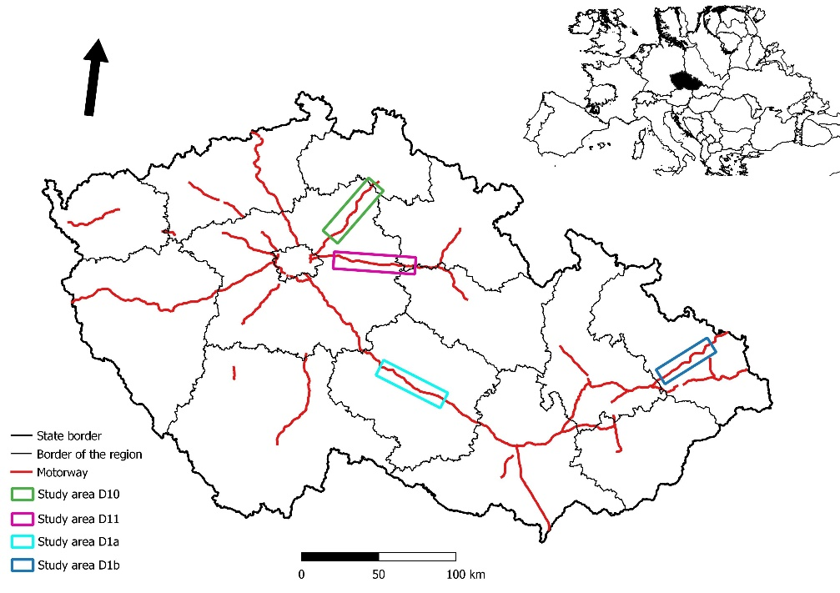

**Fig. 1.** Motorway network in the Czech Republic and the location of study areas.

*2.2 Study sites*

We settled 79 transects with totally 298 plots. One transect involved 4 plots of size 50x50 m in the distances of 25 m, 125 m, 500 m and 1000 m from the edge of the motorway (Fig. 2). Only transects in the study area D1a was 3 plots designed in distances of 25 m, 500 m and 1000 m from the edge of the motorway. The study area D1a was counted first as a pilot area and the fourth distance was added to other three study areas in order to ensure more precisely results. Selection of suitable transects was based on orthophoto maps (© Seznam.cz a.s., 2020) and then the on-site verification. All the transects had to meet other requirements. To prevent pseudo replication of the data, transects were spaced at least 1000 m apart. Another condition was a minimum distance of 500 m from the nearest forest and village, in order to eliminate their influence on bird census on transects.

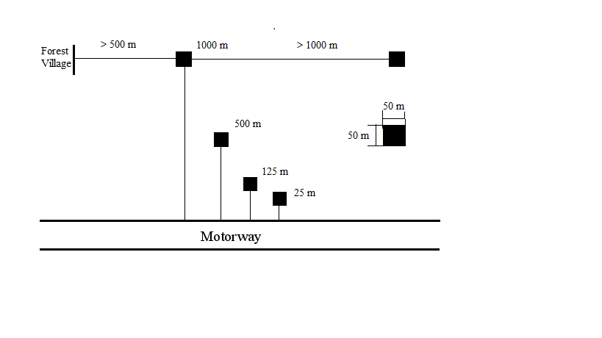

**Fig. 2.** Design of the study plot.

2.3 *Bird survey*

We used the point-count method for bird census (Bibby et al., 1992; Gregory et al., 2004). We carried out two visits at every plot and recorded the presence of each species there, while 10 minutes observing, slowly walking, using binoculars. Observations were conducted in early morning, from sunrise for 4 hours, due to peak hours of bird song activity, but not during windy and rainy days. Visible and audible individuals of species were recorded. Birds of species that flew over the plot were not included into dataset due to possible duplication of the bird from previous plot or transect. The bird census was carried out from April till May in four years (2008, 2010, 2011, 2020) by four people.

*2.4 Additional variables*

We assigned several environmental factors to every plot. Distance from the forest was measured from the edge of the plot to the nearest forest. Similarly, in the case of distance to village, this distance was measured from the edge of the plot to the nearest village. The environment of the plot was described by the percentage cover of shrubs and percentage cover of trees. Factors such as presence of water bodies, fields, meadows, and ruderal vegetation were determined by observation in every plot. The elevation of the plot was determined from maps (© Seznam.cz a.s., 2020). Traffic volume was obtained from the traffic count portal of the Road and Motorway Directorate of the Czech Republic (2016).

*2.5 Statistical analysis*

We evaluated the effect of distance to motorway on bird species richness using generalized mixed effect models (GLMM). First, we fitted a model with species richness of all bird species as a response variable and distance to motorway (m) as a fixed effect predictor. We used a Poisson distribution with log link function. To account for differing habitat characteristics of the plots, we also included distance to the nearest forest (m), distance to the nearest village (m), percentage cover of shrubs (%), percentage cover of trees (%), presence of water bodies, fields, meadows, and ruderal vegetation (0/1 factors), and elevation (m) as fixed effect covariates. To account for the differences in traffic intensity between the sites, we also added traffic volume of the corresponding motorway (AADT) as a (fixed) covariate. Because each motorway was sampled in a different year by different researcher, we included the motorway ID as a random intercept term. To account for any possible conditions specific to a given transect that are not captured by the fixed covariates, we also included the transect ID as a random intercept, nested within the motorway ID. We then fitted other eight models, with the same predictor structure (both fixed and random) as described above, but with species richness of a certain subset of species as a response variable. First, to see whether the effect of the predictors differ according to the habitat, we fitted separate models for farmland species and for woodland species. Second, we divided the species according to the nesting guilds to canopy, cavity, ground, and shrub nesters, and fitted a separate model to each of them. And third, we also investigated whether the effects differ according to the trophic guilds by fitting separate models for granivores and insectivores.

With each model, we first applied the following model selection to the random effect terms. We compared a model with the full random-effect structure (i.e., the random intercept effect of transect nested within the random-intercept effect of motorway) with a model with only random-intercept effect of motorway, using likelihood ratio test (LRT, function anova in R). If we found the effect of transect insignificant, we then compared the model with the effect of motorway with a model with no random effects (i.e., a Poisson GLM) in the same way. However, in four out of nine models, the simple model structure was adopted because the more complex structure resulted in a singular model fit (see Tab. 1). After determining the random effect structure, we checked for multicollinearity of the fixed predictors using variance inflation factor (VIF). Then we proceeded with the selection of fixed predictors, using the backward selection based on Akaike information criterion (AIC). In the final model, the significance of the predictors was assessed using LRT comparing the full model with a model excluding the evaluated predictor. The goodness of fit was assessed by the Nagelkerke’s pseudo R2 (Nagelkerke, 1991) resp. the marginal Nakagawa’s R2 (Nakagawa et al., 2017) for the GLM resp. GLMM models. We also assessed the importance of individual predictors as the R2 of the full model minus the R2 of the model with the given predictor excluded, roughly estimating the percentage of the response variability explained due to the given predictor.

Because the hypothetical effect of distance to motorway on species richness would probably be due to the associated traffic noise, we also tried using the category of noise level (as measured by noise maps) (Ministry of Health of the Czech Republic, 2017). as a predictor of species richness instead the distance to motorways. The category of noise level has an advantage that it is directly linked to the probable cause of the effect of motorways on birds, although its disadvantage is that it is only roughly estimated based on NMPB-Routes-96, which is French national method for noise mapping in application of Directive 2002/49/EC (Besnard et al., 2009; Ministry of Health of the Czech Republic, 2017), categorizing the noise into levels 1 (< 45 dB), 2(45 – 65 dB), 3 (65 – 75 dB), and 4 (> 75 dB) and it ignores any other possible effect of motorways (e.g. the air pollution, habitat alteration, etc.). We compared the models with distance to motorways and with noise level (keeping the structure of all other predictors unchanged) using AIC, evaluated after the backward stepwise AIC-based variable selection.

**3 Results**

The model using noise levels instead of distance to motorway resulted in 6 points lower AIC value compared to the model with distance to motorway (AIC 1217 vs AIC 1211). Therefore, the distance to motorway proved to be slightly more effective predictor of bird species richness and we thus based all our further results on the models with this predictor.

Models on average explained 35 (+- 16) % of species richness variability (see Tab. 1). Model for all species explained 47 %. The model for woodland species performed much better than the one for farmland species (42 % compared to 22 %). In terms of nesting guilds, the model for shrub nesters performed best (52 % compared to 14 % for ground nesters and 32 % for cavity nesters). The model for insectivores showed the best overall performance (60 % compared to 19 % for granivores).

**Tab. 1.** Summary of the fitted models.

|  |  |  |  |  |
| --- | --- | --- | --- | --- |
| *Response* | *Model* | *R2 a* | *Random effects* | *Note* |
| All species | GLMM | 47.3 | (1 | highway) |  |
| Farmland | GLMM | 22.3 | (1 | highway) |  |
| Woodland | GLMM | 42.0 | (1 | highway / transect) |  |
| Ground | GLMM | 14.4 | (1 | highway) | Singular fit |
| Shrub | GLM | 51.6 | - |  |
| Canopy | GLMM | 24.0 | (1 | highway) | Singular fit |
| Cavity | GLM | 31.9 | - | Singular fit |
| Insectivores | GLM | 59.9 | - |  |
| Granivores | GLM | 18.7 | - | Singular fit |

a For GLM models, the Nagelkerke’s pseudo R2 was used; for GLMM models, the Nagakawa’s marginal R2 was used.

In most of the models, the distance to motorway was the most important predictor, explaining about 15 % of the overall species richness variability, and about 20 % of the shrub nesters richness and insectivores’ richness variability (Fig. 3). The exceptions are woodland species, where the most important predictor was tree cover (ca 20 %), and canopy nesters, with traffic volume being most important (ca 10 %), but even for these models the distance to motorway was relatively important (9 % resp. 7 %). The tree cover was the second most important predictor in many models, followed by elevation, which played especially important role for shrub nesters (ca 20 %). The importance of the rest of the predictors were below 5 %.

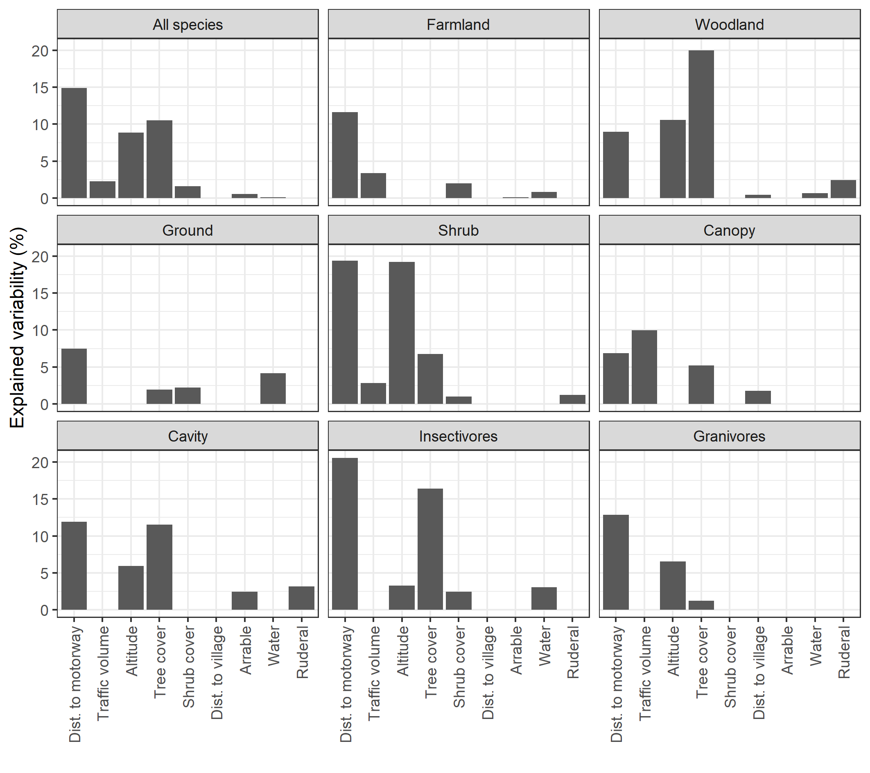

**Fig. 3.** The importance of individual predictors in the GLMM models of species richness as a response variable, for all species combined (first panel) as well as for different groups of species (rest of the panels). The variable importance has been computed as the difference in R2 values between the model with and without the predictor. For GLM models, the Nagelkerke’s pseudo R2 was used; for GLMM models, the Nakagawa marginal R2 was used.

The individual model coefficients together with the associated standard errors are summarized in the Fig. A1, Appendix. The effects of individual predictors are visualized in the prediction plots, Figs. 4 - 6. For all species together, the mean number of species increased from 2 to 6 with the distance from the motorway increasing from 0 to 1.25 km. A similar increase (from 2 to 6 species) was found as an effect of tree cover increasing from 0 to 60 %. The effects of other significant predictors (positive effect of shrub cover and negative effects of distance to village and traffic volume) were rather weak (about one species increase/decrease over the range of the observed predictor values). The effect of presence of water and presence of ruderal vegetation were even weaker, less than one species increase.

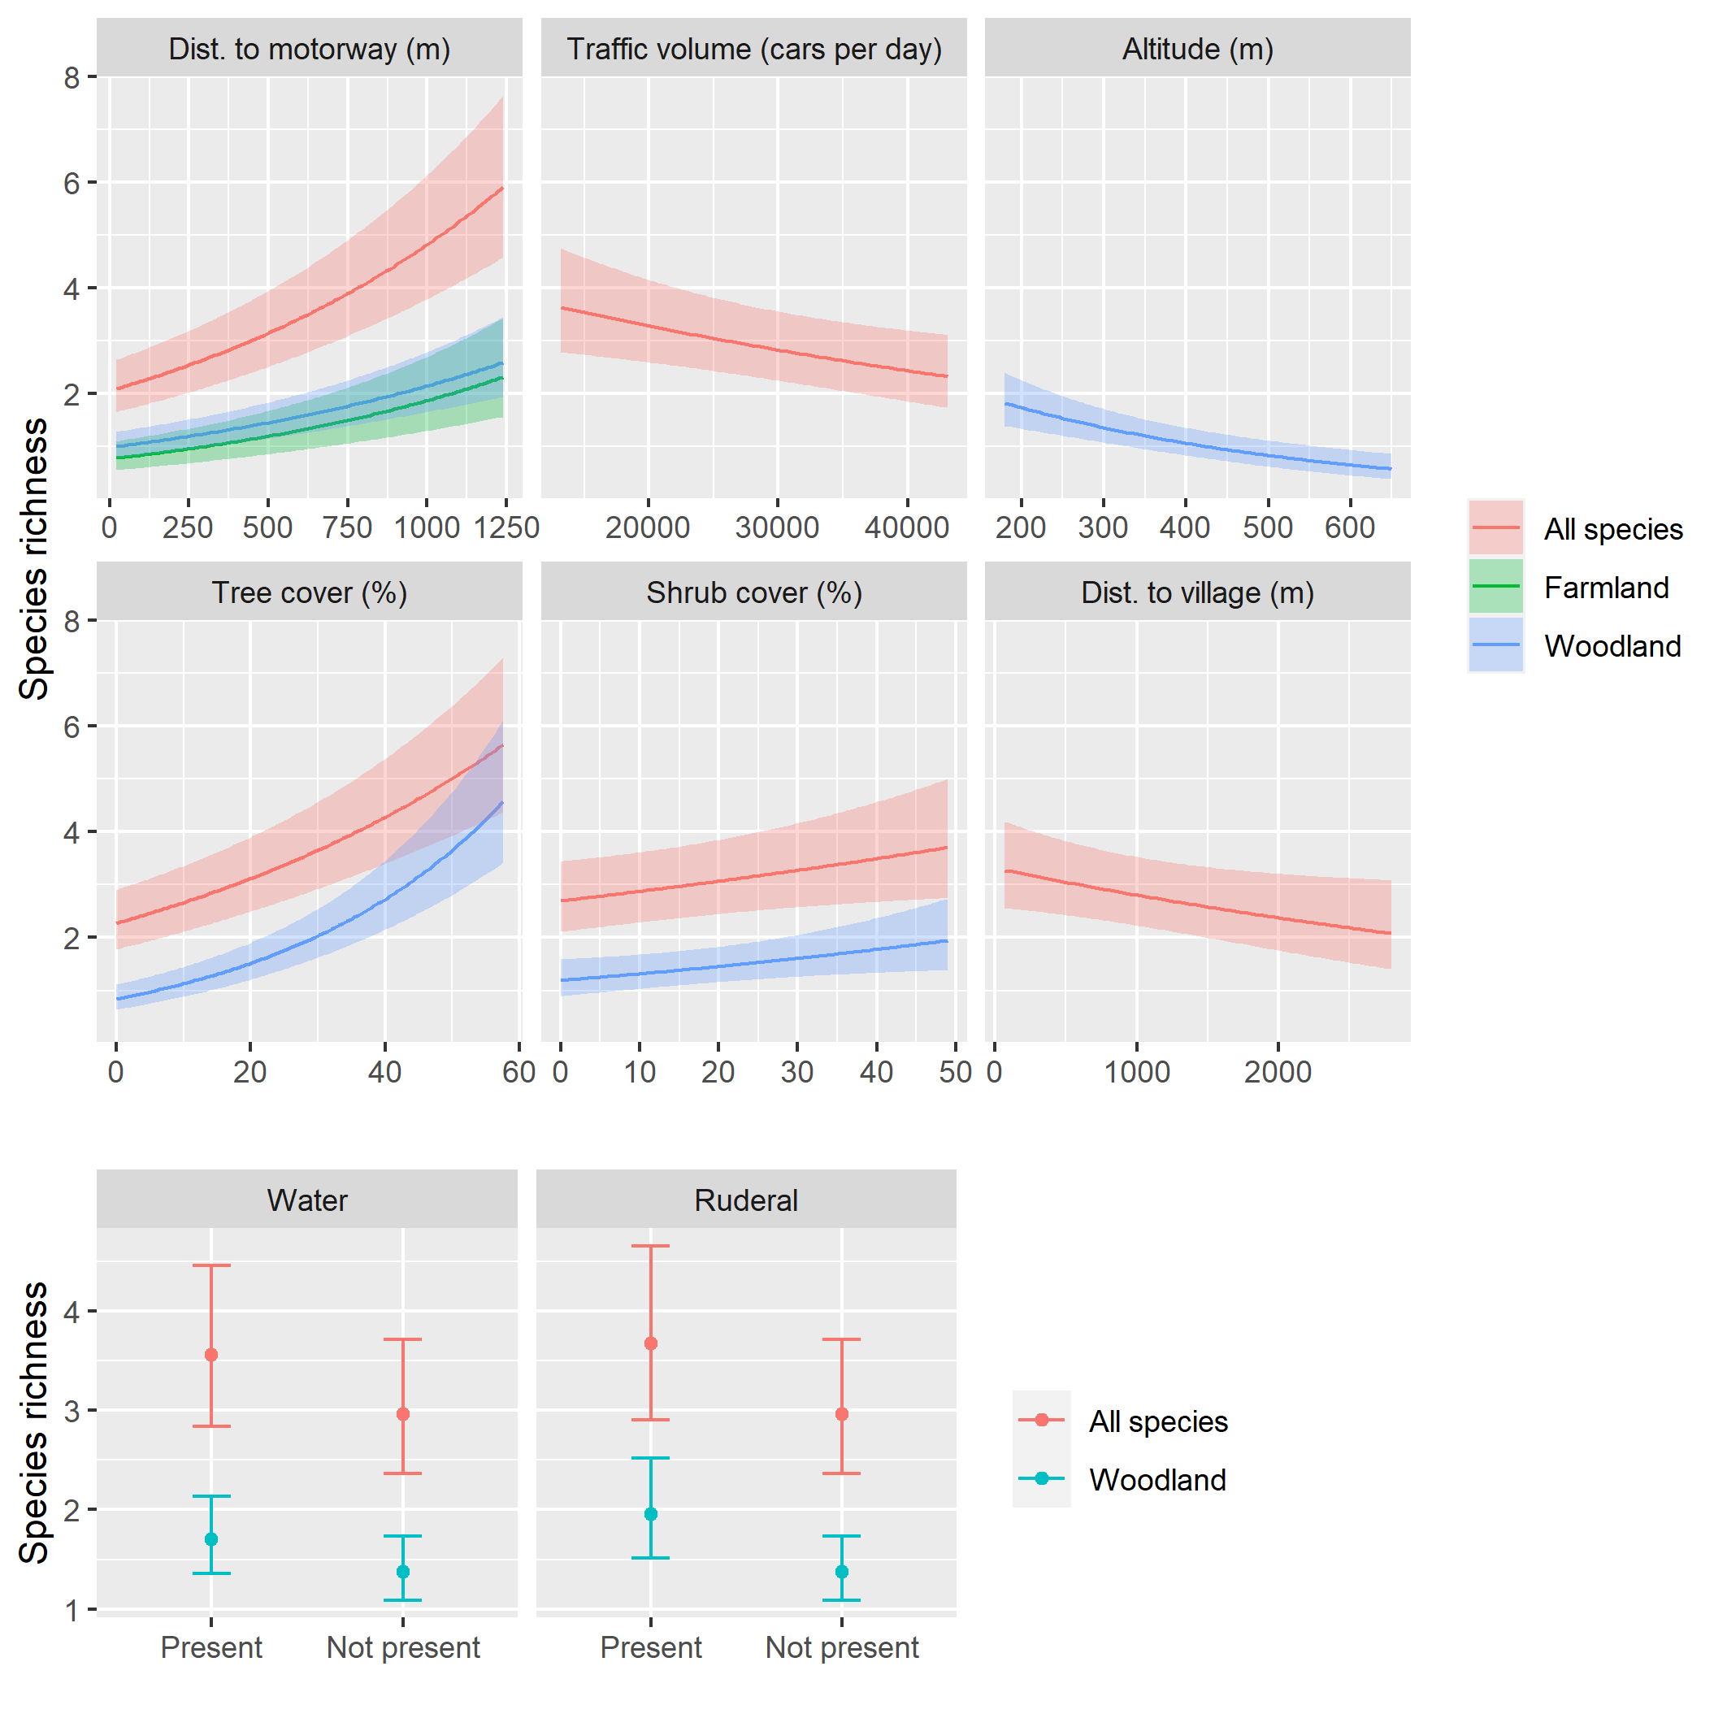**Fig. 4.** Prediction plots for individual predictors, from the GLMM models with species richness as well as farmland and woodland species richness as a response variable. For each predictor displayed, all other predictors in the model are set to their mean observed value (for continuous predictors) or to 0 (for factors). Only significant predictors are shown.

Woodland species richness exhibited similar effects (with lower magnitude corresponding to the lower number of species) of distance to motorway, shrub cover, tree cover, and water and ruderal vegetation, while it was also negatively associated with elevation (Fig. 3). Compared to all species, there was no effect of distance to village and traffic volume. Farmland species, on the other hand, only exhibited a weak positive effect of distance to motorway.

+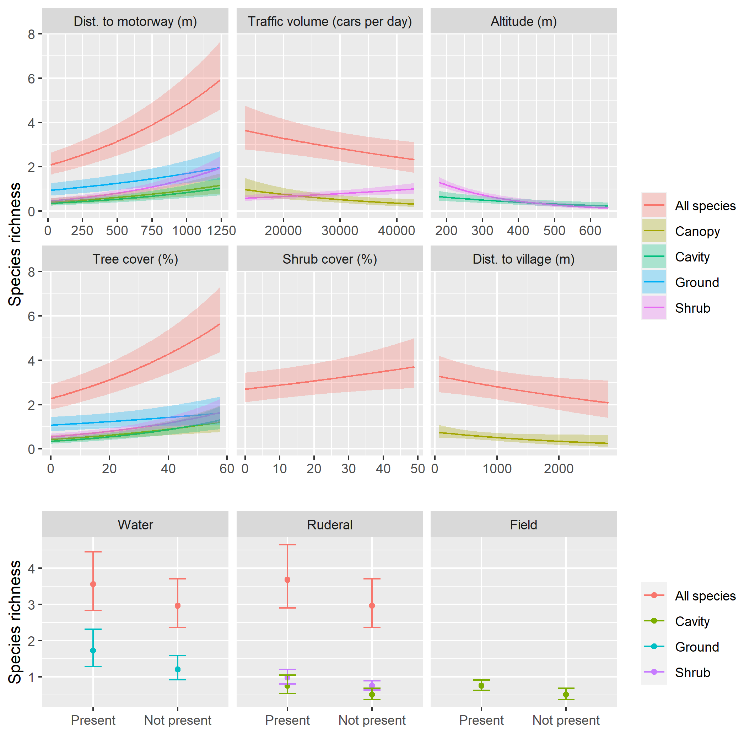

**Fig. 5.** Prediction plots for individual predictors, from the GLMM models with species richness as well as cavity, ground, and shrub nesters species richness as a response variable. For each predictor displayed, all other predictors in the model are set to their mean observed value (for continuous predictors) or to 0 (for factors). Only significant predictors are shown.

In terms of nesting guilds, all guilds showed positive effects of distance to motorway and tree cover, the effect being relatively strongest for shrub nesters (Fig. 5). Shrub nesters richness was also positively associated with traffic volume and presence of ruderal vegetation, while it was negatively associated with elevation. Canopy nesters were slightly negatively associated with distance to village. Cavity nesters showed a weak positive effect of presence of fields and ruderal vegetation. And finally, ground nesters were positively associated with presence of water and negatively with elevation.

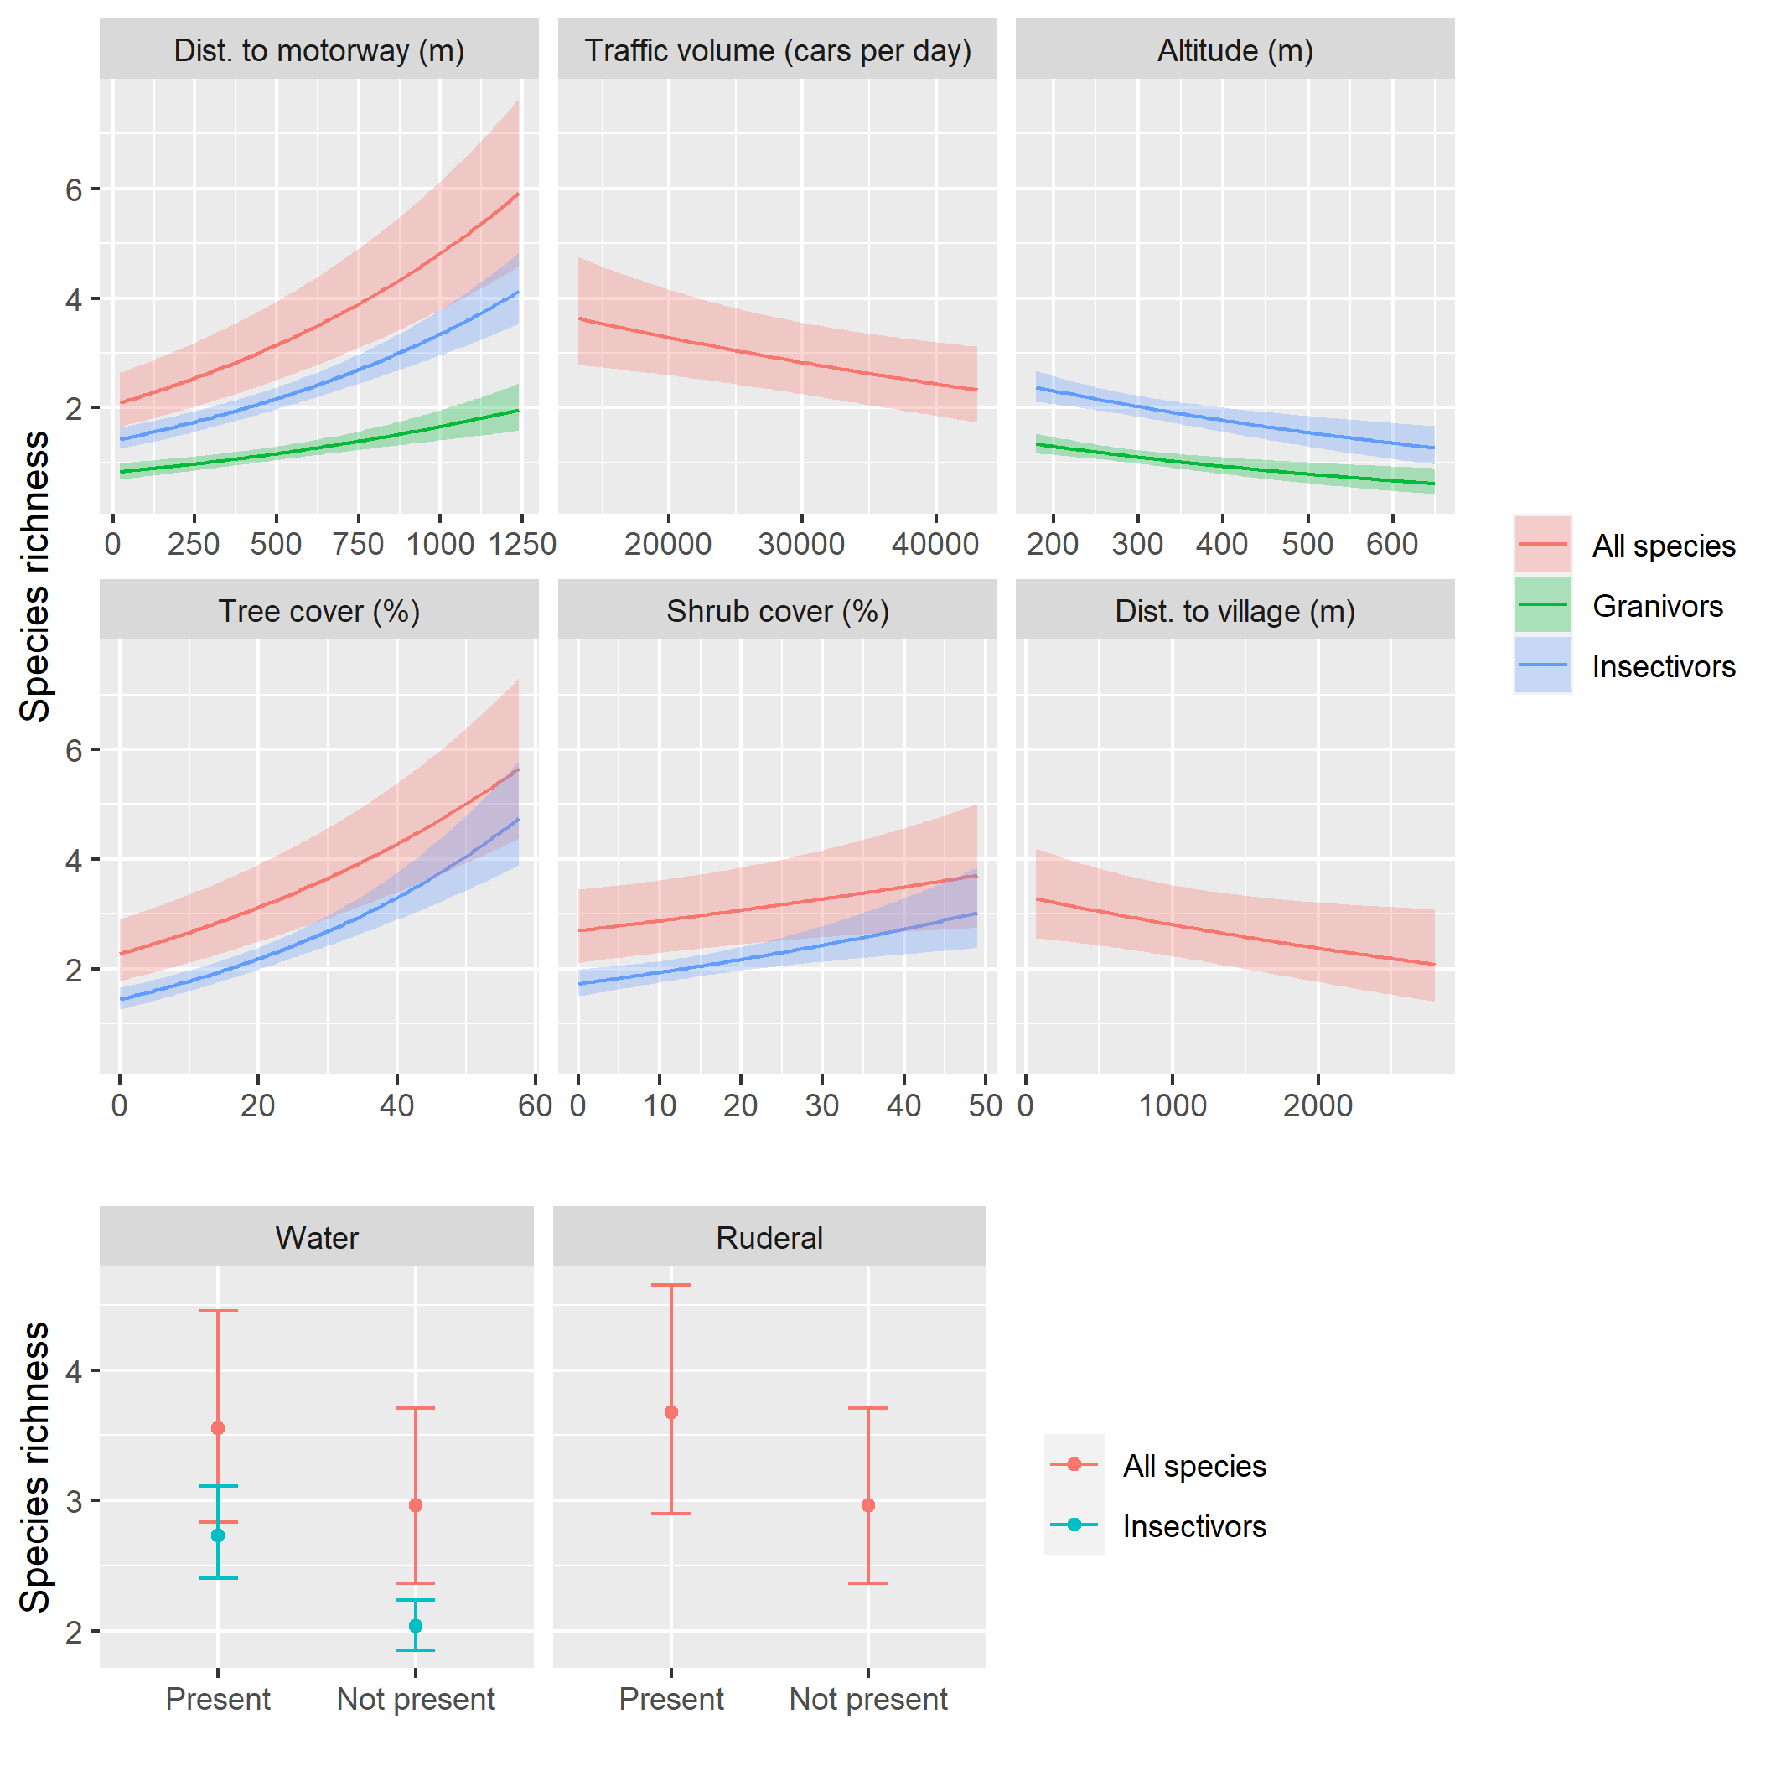

**Fig. 6.** Prediction plots for individual predictors, from the GLMM models with species richness as well as granivorous and insectivorous species richness as a response variable. For each predictor displayed, all other predictors in the model are set to their mean observed value (for continuous predictors) or to 0 (for factors). Only significant predictors are shown.

Both food guilds showed positive effects of distance to motorway as well as negative effects of altitude on species richness (Fig. 6). Insectivorous species richness was further positively associated with tree and shrub cover and the presence of water.

**4 Discussion**

**Road traffic**

To evaluate the impact of the motorway on the bird species richness which were detected, we compared models using noise levels and distance from the motorway. We found out distance from the motorway as a slightly more effective predictor of bird species richness in contrast to noise level, therefore all further models results were based on this predictor. This approach confirms Summers et al. (2011) who found out that the association between distance from road and bird species richness was stronger than the influence of traffic noise. Our survey is in accordance with studies realised by Reijnen et al. (1996); Forman et al. (2002); Kuitunen et al. (2003) and Polak et al. (2013); Xie et al. (2021); Wiacek (2023), the bird species richness increases with increasing distance from motorway. The study of Summers et al. (2011) was carried out in woodland close to forest edge adjacent to farmland or grassland in Canada with traffic volume 13 700 - 87 100 AADT. Other causes beyond noise are likely to have an impact on bird species richness. According to Summers et al. (2011) road mortality brings higher impact on birds compared to noise. Road mortality is occurred much more in high traffic volume roads compared to roads with low traffic volume (Orłowski, 2008). Other survey conducted by Jack et al. (2015) in woodland shows that places with high risk of birds traffic collisions, have a smaller number of forest bird species. They also found higher bird abundance close to roads than farther away. In our study, the impact of motorways on bird species was represented by the motorway distance, which characterized the greatest impact for the species richness of all the birds as well as for most of birds sorted into different groups. Our results are consistent with findings of studies realised in farmland or open habitat (Reijnen et al., 1996; Forman et al., 2002; Clarke et al., 2013; Xie et al., 2021) and in woodland (Kuitunen et al., 2003; Herrera-Montes & Aide, 2011; Polak et al., 2013; Wiacek et al., 2015), that the number of species increased with increasing distance from the motorway. Only study conducted by Brotons & Herrando (2001) dealt with an environment similar to ours, namely the effect of motorway distance on birds in farmland with scattered tree and scrub vegetation. According to Husby (2017) habitat quality is positively correlated with the road distance. However, low habitat quality together with high traffic noise can be beneficial in reduction of the road mortality of bird species (Wiacek, 2023).

In our study, species richness was also significantly influenced by traffic volume. This effect was somewhat weaker, but the results clearly demonstrate that the bird species richness declined as traffic volume increased (Reijnen et al., 1996; Forman, 2000; Brotons & Herrando, 2001; Forman et al., 2002; Summers et al., 2011).

We also found other significant factors that, together with motorway distance influenced the overall bird species richness. The strongest factor turned out to be the tree cover in every plot. This dependence has also been confirmed by Khanaposhtani et al. (2019). However, it is in contrast with Kroeger et al. (2022) who found lower bird species richness in areas with denser tree cover. Farmland bird species were not impacted by tree cover, because they are typically linked to open habitats. Hall et al. (2018) even observed that the increase in tree cover led in a decrease in the number of species inhabiting the open habitats.

In addition, other factor shrub cover, showed a smaller but still significant effect compare to tree cover. Another significant factor proved to be the distance from the village. The results showed that the species richness of birds declined as the distance between the plot and the village grew. This may be related to the fact that villages serve as hot spots of bird richness in agricultural landscape. Especially old farmsteads and homesteads provide more heterogenous habitat structure resulting in better nesting opportunities and also food sources (Hiron et al., 2013; Rosin et al., 2016). Villages with old homestands are consist of different features e g. *ponds, gardens, farm animals and farm residues (e.g. grain, manure)* that create mosaic environment and thus those areas are more heterogenous in contrast to agricultural landscape (Rosin et al., 2016).

***4.1 Habitat of bird species***

Our findings also revealed that motorway distance had a significant effect on the abundance of bird species inhabiting forests and agricultural landscapes. The species richness of both groups of birds increased with distance from the motorway, with forest birds benefiting slightly more. The greater influence of woodland bird species versus farmland bird species differs from previous research. This difference may be caused by the fact that we recorded more woodland species (36) than farmland species (22). In addition, woodland species were more abundant and frequent in the plots compare to farmland species and this could also play a role in the difference. Forman (2000) claims that agricultural bird species are affected over a longer distance (365 m) compared to forest species (305 m). These results were obtained from a road with traffic volume about 10 000 AADT. Different lengths of influence on birds are explained by the fact that noise in farmland spreads farther in comparison with woodland (Forman et al., 2002). The effect of the road distance over which it affects birds in its vicinity also depends on the traffic volume. Population of most farmland birds decreases with the traffic volume 5000 AADT or even less (Reijnen et al., 1996). This traffic volume caused decrease in abundance of 12 - 56 % bird species distant up to 100 m from the road. The same distance effect of traffic on bird species was found by Wiacek (2023), with the difference that the traffic volume was 7 650 AADT. Palomino & Carrascal (2007) observed a greater impact of the road on birds over 300 m, but at the same traffic volume. In contrast, Forman et al. (2002) found no significant effect with similar traffic volume (3000 – 8000 AADT) for grassland birds. Furthermore, traffic volume about 30 000 AADT causes an overall decline in bird species up to 700 m in farmland. In the case of traffic volume higher then 30 000 AADT, birds avoid motorway about 1200 m far (Forman et al., 2002). Another study conducted by Reijnen et al. (1996) with traffic volume 50 000 AADT documented population loss of between 40 – 74 % of all breeding species within 100 m motorway distance and 12-52% within 500 m. Nevertheless, they mention some species such as lapwing (*Vanellus vanellus*), skylark (*Alauda arvensis*) that declined in population of 14-44% within 1500 m. The most prone birds are endangered species and those who predominately occupy open habitats such as common linnet (*Carduelis cannabi*na), common quail (*Coturnix coturnix*), corn bunting (*Emberiza calandra*), stonechat (*Saxicola torquata*), Whinchat (*Saxicola rubetra*) (Palomino & Carrascal, 2007; Ascensao et al., 2022; Wiacek, 2023).

Furthermore, one study conducted by Brotons & Herrando (2001) is little bit similar to our study. They researched an impact of road traffic on bird species in Mediterranean farmland with isolated pine forest fragments with traffic volume in average 47 000 AADT. They found fewer woodland species in forest fragments located close to the motorway with this effect extending up to 2 km (Brotons & Herrando, 2001).

Additionally, presence of woodland bird species was more influenced by another factor, mainly tree cover and they were strongly associated with proportion of tree cover in the study plot. This can be due to the fact, that woodland species are used to live in wooded habitats and therefore their species richness were increasing. Areas consisting of deciduous tree didn’t show any negative impact of the roadside (Palomino & Carrascal, 2007). In this case they put it into connection with edge effect, by which some bird species are attracted. On the contrary, as we expected, there was no effect of tree cover on farmland bird species. The higher farmland species richness is associated also with higher habitat diversity, resulting in mosaic different landscape land use e. g. leys, pastures or farmyards with animals (Bosco et al., 2024).

***4.2 Nest guilds***

Almost every category of birds divided by nest guild reported the same slight increase with motorway distance. Only shrub species were increasing more than the others. Sensitive and therefore negatively affected by the road traffic are ground-nesting species, with low-frequency calls. The loss of birds nesting on the ground closest to the road can have many causes, such as collisions with vehicles or noise which is the most marked on the ground resulting in reduction of habitat quality (Polak et al., 2013; Ascensão et al., 2022). Ground nesters avoid the proximity of motorway to prevent their calls being masked by the traffic noise (Polak et. al., 2013), e. g. yellowhammer (*Emberiza citrinella*) decreased song duration close to motorway in response to high traffic volume and related traffic noise in farmland. Yellowhammer also started singing later under higher traffic volume (Ritz-Radlinská et al., 2023). Clarke et al. (2013) observed negative effect of road traffic on nest density of stone curlew (*Burhinidae*) at a distance of at least 1000 m. Other typical species of open farmland, nesting on the ground is the gray partridge (*Perdix perdix*) who avoids roads and other traffic corridors (Harmange et al., 2021). This could support our result that more ground nesters were found farther from motorway, due to high noise levels in the vicinity of motorway and good noise propagation. Most of ground species recorded in our study are farmland species. Due to better noise propagation in farmland, they may be more affected by noise and forced further from the motorway. On the other hand, no effect of road distance on cavity birds found out Polak et al. (2013) and Kuitunen et al. (2003) in the case of pied flycatcher in woodland. Nevertheless, nests of pied flycatcher closer to road were more unsuccessful. Study of Kuitunen´s et al. (2003) has some limitations because, they established nest boxes only in up to 120 m far from road. However, both of the previously mentioned studies were carried out in the woodland and in an area with much lower traffic volume compared to our study. Noise and therefore also the proximity of the road has a negative effect on the nesting success of the cavity nester the great tit (Halfwerk et al., 2011).

In contrast to our results are findings of Polak et al. (2013) who found out canopy birds most abundant closer to road. Surprisingly, we found out the positive effect of traffic volume on shrub nesters richness which contrasted with the negative effect of this variable on canopy nesters as well as all species together.

Furthermore, all the nest guilds showed a slight increase with higher tree cover. Canopy birds benefit from the presence of mature alleys (Orlowski, 2008).

***4.3 Food guilds***

According to our results, number of insectivorous bird species increased with increasing distance from motorway and also were more influenced compare to granivorous. It can be due to different number of species sorted as insectivorous (47) and granivorous (16). The growth of insectivorous species from a road confirms Polak et al. (2013). In comparison to our work, the road had a considerably lower traffic volume and the number of insectivorous species increased noticeably just within 310 m of the road. The low abundance of insectivorous species closest to the road may be directly related to the negative impact of the road on insects in its vicinity. Insects are killed by passing cars and this effect increases with traffic volume. At the same time, the road is a barrier, especially for small species and flightless species insects (Muñoz et al., 2015). However, our result is not consistent with Wiacek´s et al. (2015) study, which describes that insectivorous bird species prefer proximity to roads. Nevertheless, their study was conducted along road in woodland with much lower traffic volume (only 8738 AADT) compared to our study. Low traffic roads and unpaved roads can increase the heterogeneity of the environment and attract different species, while at higher traffic volumes the negative effects of traffic become fully apparent (Šálek et al., 2010; Kroeger et al., 2022). In addition, the road edge effect may also contribute to species' preference for roadside habitats (Polak et al., 2013; Wiacek et al., 2015). The number of granivorous species in our study also increased with increasing distance from the motorway, but considerably less than in the case of insectivorous species. The same result also reached Wiacek et al. (2015) in their study. On the other hand, study conducted by Polak et al. (2013) shows that granivorous species decreased with increasing distance. However, this decrease was observed only within 300 m of the motorway. It´s interesting, that both studies (Polak et al., 2013; Wiacek et al., 2015) were conducted Poland in very similar habitats but provide different results.

Granivorous species were found having a significant high roadkill rate (Cook & Blumstein, 2013). In general, higher abundance of some bird species closer to road and high road kill rate can be explained that road verges may attract birds due to edge effect and may play important role when they provide better availability of any resource than surrounding habitats farther (Meunier et al., 1999; Palomino & Carrascal, 2007; Cook & Blumstein, 2013).

Additionally, insectivorous species were also affected by tree and shrub cover, with their species richness increasing with higher cover of both vegetation types. Furthermore, in our study, both food guilds were additionally influenced by altitude. Bird species slightly decreased while the altitude increased.

In our paper we did not evaluate omnivorous bird species due to the low representation of this group. Nevertheless, Kroeger et al. (2022) found omnivorous birds surviving better in roadside habitats compare to birds with specialised feeding requirements (i.e. insectivores and granivores). Omnivorous birds are less food specialised and they can advantage from the presence of roads (Kroeger et al., 2022). Their more extensive foraging specialization may result in a notably higher frequency of vehicle collisions (Cook & Blumstein, 2013). Carnivores are another group that we did not evaluate due to their low presence in number of species. Nevertheless, Kroeger et al. (2022) found no positive effect on carnivores. Rytwinski & Fahrig (2013) reached a similar result concerning carnivorous bird species. They specifically mention vultures as a species who doesn´t increase with increasing traffic volume. In contrary, positive effect of roads on carnivorous species was reached by Meunier et al. (2000) and Morelli et al. (2015). Meunier et al. (2000) found out raptors e. g. buzzards (*Buteo buteo*), kestrels (*Falco tinnunculus*) and black kites (*Milvus migrans*) significantly more abundant in road verges than in open agricultural landscape. This relation was found throughout the winter, due to hunting and perching sites of raptors (Meunier et al., 2000).

***4.4 Management measures and recommendations***

Our findings and previous studies lead us to suggest appropriate measures to support bird species in the landscape along motorways and to mitigate their negative impact. The purpose is to enhance the heterogenous habitats in uniform farmland for farmland bird species in relation to the high traffic volume motorways that cross the area and provide them better food and nest opportunities in contrast to roadside habitats. Therefore, we suggest planting measures along motorways at least at a distance of about 500 m from them and also depending on traffic volume of the motorway in support of farmland species. Measurements are often applied on the edges of agricultural land, which is very often in close proximity to roads with varying traffic volume. Establishing the appropriate distance is crucial to preventing vegetation from serving as an ecological trap for birds in the context of traffic as they attract birds to their vicinity and birds are at a higher risk of collisions with vehicles. Measures such as fallow land, flower strips and scattered tree and shrub are specifically targeted on farmland bird species who nest on the ground and thus they are sensitive to motorway traffic.

In addition, we also propose to increase planting trees within 100 m from the motorway in order to support woodland species which are predominantly canopy and cavity species, thus they are the least road affected species and to mitigate the negative effects of the traffic on the surrounding area. Roadside vegetation can serve as carbon sinks, reduce light and noise pollution (Milton et al., 2015), so that the presence of scattered tree and shrub vegetation reduces noise pollution in the vicinity of the motorway as well as reduces the spread of light pollution, dust and other pollutants, thus minimising the negative impacts of motorway traffic on the surrounding landscape.

Specific measures are foreseen in e.g. Nature restoration law and The European Green Deal, that aim to improve biodiversity in agricultural landscape by enhancing certain biodiversity-rich landscape features such as hedgerows, flower strips, fallow land, pockets of trees. The same measures also cover EU Biodiversity Strategy for 2030. These measures immediately result in more pollinators and thus consequently positively affect abundance of bird species in agricultural landscape (European Commission, Directorate-General for Environment, 2021; European Commission, Directorate-General for Environment, (2022).

Within the framework of our study, we would advise against implementing the subsequent measures in the vicinity of a road network with high traffic volume, at least 500 m far from it.

**5 Conclusion**

Birds inhabiting agricultural landscape are highly endangered and their numbers are steadily declining. This is due to the intensification of agriculture and associated changes in the landscape such as the consolidation of fields and the loss of landscape features. Motorways might be a factor in this unfavourable pattern. According to our results, we found negative effect of motorways on bird species richness in farmland with scattered tree and shrub vegetation. This is the first study which examine how traffic affects bird species richness in this type of habitat. Overall bird species richness increased with increasing distance from motorway and decreased with traffic volume. We also sorted bird species according to their habitat, nest and food preferences, and we found the negative effect of motorway distance on woodland and farmland species richness. The same negative effect was detected for insectivorous and granivorous species richness. Species richness sorted by nest guilds also showed a negative effect of motorway distance, nevertheless the impact was much weaker.

**Acknowledgments**

We would like to thank Musilová Eliška, Šťastný Petr and Maršálková Kateřina for their help with collecting data. This study was funded by the Faculty of Environmental Sciences, Czech University of Life Sciences, Prague (Grant No. 2022B0015).

**References**

Arévalo, J. E., & Newhard, K. (2011). Traffic noise affects forest bird species in a protected tropical forest. *Revista de Biologia Tropical*, 59 (2), 969-980.

Ascensão, F., D'Amico, M., Revilla, E., & Pereira, H. M. (2022). Road encroachment mediates species occupancy, trait filtering and dissimilarity of passerine communities. *Biological Conservation*, 270, 109590.

Benítez-López, A., Alkemade, R., & Verweij A. P. (2010). The impacts of roads and other infrastructure on mammal and bird populations: A meta-analysis. *Biological Conservation*, 143, 1307–1316. https://doi.org/10.1016/j.biocon.2010.02.009

Bibby, C. J., Burgess N. D., & Hill, D. A. (1992). Bird census techniques. *Academic Press*, London, ISBN 0120958317.

Bíl, M., R. Andrášik, T. Svoboda, & J. Sedoník. (2016). The KDE+ software: a tool 390. for effective identification and ranking of animal-vehicle collision hotspots along networks. *Landscape Ecology*, 31(2), 231-237.

Bíl, M., Andrášik, R., Duľa, M., & Sedoník, J. (2019). On reliable identification of factors influencing wildlife-vehicle collisions along roads. *Journal of environmental management*, 237, 297-304.

Bíl, M., Kušta, T., Andrášik, R., Cícha, V., Brodská, H., Ježek, M., & Keken, Z. (2020). No clear effect of odour repellents on roe deer behaviour in the vicinity of roads. *Wildlife Biology 2020* (4), wlb.00744.

Besnard, F., Defrance, J., Bérengier, M., Dutilleux, G., Junker, F., Gauvreau, B., Ecotiere, D., van Maercke, D., Abbaléa, F., Baulac, M., Bonhomme, B., Lefèvre, H., Steimer, V., Zouboff, V., & Le Duc E. (2009). Road noise prediction-2-Noise propagation computation method including meteorological effects (NMPB 2008). *SETRA*, september.

Bosco, L., Lehikoinen, A., Piha, M., Seimola, T., Tiainen, J., & Ekroos, J. (2024). Relative effects of arable land-use, farming system and agri-environment schemes on landscape-scale farmland bird assemblages. Landscape Ecology, 39(6), 1-18.

Bowler, D. E., Heldbjerg, H., Fox, A. D., De Jong M., & Böhning-Gaese, K. (2019). Long-term declines of European insectivorous bird populations and potential causes. *Conservation Biology*, 33(5), 1120–1130. doi: 10.1111/cobi.13307

Brotons, L., & Herrando S. (2001). Reduced bird occurrence in pine forest fragments associated with road proximity in a Mediterranean agricultural area. *Landscape and Urban Planning*, 57 (2), 77-89. doi:10.1016/S0169-2046(01)00191-8

Brumm, H. (2004). The impact of environmental noise on song amplitude in a territorial bird. *Journal of Animal Ecology*, 73, 434-440.

Burns, F., Eaton, M. A., Barlow, K. E., Beckmann, B. C., Brereton, T., Brooks, D. R., Brown, P. M. J., Fulaij, Al N., Gent, T., Henderson, I., Noble, D. G., Parsons, M., Powney, G. D., Roy H. E., Stroh, P., Walker, K., Wilkinson, J. W., Wotton, S. R., & Gregory, R. D. (2016). Agricultural management and climatic change are the major drivers of biodiversity change in the UK. *PLOS ONE*, 11, (3). https://doi.org/10.1371/journ al.pone.0151595

Clarke, R. T., Liley, D., Sharp, J. M., & Green, R. E. (2013). Building development and roads: implications for the distribution of stone curlews across the Brecks. *PLoS One*, 8 (8), e72984.

Coffin, A. W. (2007). From roadkill to road ecology: a review of the ecological effects of roads. *Journal of transport Geography*, 15 (5), 396-406.

Cooke, S. C., Balmford, A., Johnston, A., Massimino, D., Newson, S. E., & Donald, P. F. (2020 a). Road exposure and the detectability of birds in field surveys. *Ibis*, 162 (3), 885-901.

Cooke, S. C., Balmford, A., Johnston, A., Newson, S. E., & Donald P. F. (2020 b). Variation in abundances of common bird species associated with roads. *Journal of Applied Ecology*, 57, 1271–1282, doi: 10.1111/1365-2664.13614

Cooke, S. C., Balmford, A., Donald, P. F., Newson, S. E., & Johnston, A. (2020 c). Roads as a contributor to landscape-scale variation in bird communities. *Nature communications*, 11(1), 3125.

Cook, T. C., & Blumstein, D. T. (2013). The omnivore’s dilemma: Diet explains variation in vulnerability to vehicle collision mortality. *Biological Conservation*, 167, 310-315.

De Jong, J., Van den Burg, A., & Liosi, A. (2018). Determinants of traffic mortality of Barn Owls (*Tyto alba*) in Friesland, The Netherlands. *Avian Conservation and Ecology*, 13 (2): 2. doi: 10.5751/ACE-01201-130202

Dulac, J. (2013). Global land transport infrastructure requirements. Paris: International Energy Agency, 20, 2014.

Erritzoe, J., Mazgajski, T. D., & Rejt, Ł. (2003). Bird casualties on European roads—a review. *Acta Ornithologica*, 38, 77–93.

European Commission, ©2020. Birds populations on the decline (online), dostupné z [cit.2022.04.06] <https://ec.europa.eu/eurostat/web/products-eurostat-news/-/edn-20200605-1>.

European Commission, Directorate-General for Environment, (2021). EU biodiversity strategy for 2030: bringing nature back into our lives, Publications Office of the European Union. https://data.europa.eu/doi/10.2779/677548.

European Commission, Directorate-General for Environment, (2022). Restoring nature: for the benefit of people, nature and the climate, Publications Office of the European Union. https://data.europa.eu/doi/10.2779/439286.

Forman, R. T. T., & Alexander, L. E. (1998). Roads and their major ecological effects. *Annual Review of Ecology and Systematics*, 29, 207-231. doi: 0.1146/annurev.ecolsys.29.1.207

Forman, R. T. T. (2000): Estimate of the area affected ecologically by the road system in the United States. *Conservation Biology*, 14, 31–35.

Forman, R. T. T., Reineking, B., & Hersperger A. M. (2002). Road traffic and nearby grassland bird patterns in a suburbanizing landscape. *Environmental Management*, 29, 782-800.

Gregory, R. D., Gibbons, D. W., & Donald, P. F. (2004). Bird census and survey techniques. *Bird Ecology and Conservation: A Handbook of Techniques*, Techniques in Ecology & Conservation.

Goodwin, S. E. & Shriver W. G. (2011). Effects of Traffic noise on occupancy patterns of forest birds. *Conservation Biology*, 25 (2), 406-411. doi: 10.1111/j.1523-1739.2010.01602.x

Halfwerk, W., Holleman, L. J. M., Lessells, M., & Slabbekoorn, H. (2011). Negative impact of traffic noise on avian reproductive success. *Journal of Applied Ecology*, 48, 210-219. doi: 10.1111/j.1365-2664.2010.01914.x

Hall, M., Nimmo, D., Watson, S., & Bennett, A. F. (2018). Linear habitats in rural landscapes have complementary roles in bird conservation. *Biodiversity and Conservation*, 27, 2605-2623.

Harmange, C., Bretagnolle, V., Pays, O., Sarasa, M., & Moreau, J. (2021). Linking personality and health to use of space in the gray partridge: perspectives for management*. European Journal of Wildlife Research*, 67(5), 81.

Herrera-Montes, M. I., & Aide, T. M. (2011). Impacts of traffic noise on anuran and bird communities. *Urban Ecosystems*, 14, 415-427.

Hiron, M., Berg, Å., Eggers, S., & Pärt, T. (2013). Are farmsteads over-looked biodiversity hotspots in intensive agricultural ecosystems?. *Biological Conservation*, 159, 332-342.

Hlaváč, V., & Anděl, P. (2001). Metodická příručka k zajišťování průchodnosti dálničních komunikací pro volně žijící živočichy. AOPK ČR Praha, 1-51 s. 80-86064-3.

Husby, M. (2017). Traffic influence on roadside bird abundance and behaviour. *Acta Ornithologica*, 52, 93-103. doi: 10.3161/00016454AO2017.52.1.009

Jack, J., Rytwinski, T., Fahrig, L., & Francis, C. M. (2015). Influence of traffic mortality on forest bird abundance. *Biodiversity and Conservation*, 24, 1507-1529.

Johnson, C., Jones, D., Matthews, T., & Burke, M. (2022). Advancing avian road ecology research through systematic review. *Transportation Research Part D: Transport and Environment*, 109, 103375.

Keken, Z., Kušta, T., Langer, P., & Skaloš, J. (2016). Landscape structural changes between 1950 and 2012 and their role in wildlife–vehicle collisions in the Czech Republic. *Land Use Policy*, 59, 543-556.

Keken, Z., Sedoník, J., Kušta, T., Andrášik, R., & Bíl, M. (2019). Roadside vegetation influences clustering of ungulate vehicle collisions. *Transportation Research Part D: Transport and Environment*, 73, 381-390.

Khanaposhtani, M. G., Gasc, A., Francomano, D., Villanueva-Rivera, L. J., Jung, J. H., Mossman, M.J., Pijanowski, B.C. (2019). Effects of highways on bird distribution and soundscape diversity around Aldo Leopold’s shack in Baraboo, Wisconsin, USA. *Landscape Urban Planning*, 192, 13. https://doi.org/10.1016/j.landurbplan.2019.103666.

Kušta, T., Holá, M., Keken, Z., Ježek, M., Zíka, T., & Hart, V. (2014). Deer on the railway line: Spatiotemporal Trends in Mortality Patterns of Roe Deer. *Turkish Journal of Zoology*, 38, 479-485.

Kušta, T., Keken, Z., Ježek, M., Holá, M., & Šmíd, P. (2017). The effect of traffic intensity and animal activity on probability of ungulate-vehicle collisions in the Czech Republic. *Safety Science*, 91, 105-113.

Kociolek, A., Clevenger, A., St. Clair, C., & Proppe, D. (2011). Effects of Road Networks on Bird Populations. *Conservation Biology*, 25 (2), 241–249. doi: 10.1111/j.1523-1739.2010.01635.x

Kuitunen, M., Viljanen, J., Rossi, E., & Stenroos A. (2003). Impact of Busy Roads on Breeding Success in Pied Flycatchers Ficedula hypoleuca. *Environmental* Management, 31, 0079–0085.

Meunier, F. D., Verheyden, C., & Jouventin, P., (1999). Bird communities of highway verges: influence of adjacent habitat and roadside management. *Acta Oecologica*, 20, 1–13.

Meunier, F. D., Verheyden, C., & Jouventin, P. (2000). Use of roadsides by diurnal raptors in agricultural landscapes. *Biological Conservation*, 92(3), 291-298.

Milton, S. J., Dean, W. R. J., Sielecki, L. E., & van der Ree, R. (2015). The function and management of roadside vegetation. *Handbook of road ecology*, 373-381.

Ministry of Health of the Czech Republic, © 2015. Metodiky výpočtu SHM. (online), [cit. 2023.11.22], dostupné z https://www.mzcr.cz/metodiky-vypoctu-shm/.

Ministry of Health of the Czech Republic, © 2017. Hlukové mapy 2017. (online) [cit. 2023.10.24], dostupné z https://geoportal.mzcr.cz/SHM2017/.

Morelli, F., Jerzak, L., Pruscini, F., Santolini, R., Benedetti, Y., & Tryjanowski, P. (2015). Testing bird response to roads on a rural environment: A case study from Central Italy. *Acta Oecologica*, 69, 146-152.

Muñoz, P. T., Torres, F. P., & Megías, A. G. (2015). Effects of roads on insects: a review. *Biodiversity and Conservation*, 24, 659-682.

Nagelkerke, N. J. (1991). A note on a general definition of the coefficient of determination. *Biometrika*, 78(3), 691-692.

Nakagawa, S., Johnson, P. C., & Schielzeth, H. (2017). The coefficient of determination R 2 and intra-class correlation coefficient from generalized linear mixed-effects models revisited and expanded. *Journal of the Royal Society Interface*, 14(134), 20170213.

Newton, I. (2004). The recent declines of farmland bird populations in Britain: an appraisal of causal factors and conservation actions. *Ibis*, 146 (4), 579-600.

Orłowski, G. (2008). Roadside hedgerows and trees as factors increasing road mortality of birds: implications for management of roadside vegetation in rural landscapes. *Landscape and urban planning*, 86 (2), 153-161.

Palomino, D., & Carrascal, L. M. (2007). Threshold distances to nearby cities and roads influence the bird community of a mosaic landscape. *Biological Conservation*, 140, 100-109. doi: 10.1016/j.biocon.2007.07.029

Pinto, P., Lourenço, R., Mira, A., & Santos M. S. (2020). Temporal patterns of bird mortality due to road traffic collisions in a Mediterranean region. *Bird Study*, 67, 71-84. doi: 10.1080/00063657.2020.1779652

Polak, M., Wiacek, J., Kucharczyk, M., & Orzechowski, R. (2013). The effect of road traffic on breeding community of woodland birds. *European Journal of Forest Research*, 132, 931-941. doi: 10.1007/s10342-013-0732-z

Reijnen, R., & Foppen, R. (1994). The effects of car traffic on breeding bird populations in woodland. I. Evidence of reduced habitat quality for willow warblers (Phylloscopus trochilus) breeding close to a highway, *Journal Applied Ecology*, 31, 85-94.

Reijnen, R., Foppen, R., Ter Braak, C., & Thissen J. (1995). The effects of car traffic on breeding bird populations in woodland, III. Reduction of density in relation to the proximity of main roads. *Journal of Applied Ecology*, 32, 187-202.

Reijnen, R., Foppen, R. & Meeuwsen, H. (1996). The effects of traffic on the density of breeding birds in Dutch agricultural grasslands. *Biological Conservation*, 75, 255–260.

Ritz-Radlinská, A., Barták, V., Hodačová, L., Maidlová, K., & Zasadil, P. (2023). The singing activity of the Yellowhammer (*Emberiza citrinella*) under traffic noise around highways. *Frontiers in Ecology and Evolution*, 11, 1020982.

Road and Motorway Directorate of the Czech Republic, ©2016. Celostátní sčítání dopravy 2016. (online) [cit. 2020.05.26], dostupné z <https://www.rsd.cz/wps/portal/web/Silnice-a-dalnice/Scitani-dopravy>.

Rosin, Z. M., Skórka, P., Pärt, T., Żmihorski, M., Ekner‐Grzyb, A., Kwieciński, Z., & Tryjanowski, P. (2016). Villages and their old farmsteads are hot spots of bird diversity in agricultural landscapes. *Journal of Applied Ecology*, 53(5), 1363-1372.

Rytwinski, T., & Fahrig, L. (2013). Why are some animal populations unaffected or positively affected by roads?. *Oecologia*, 173, 1143-1156.

Slabbekoorn, H., & Ripmeester, E. A. P. (2008). Birdsong and anthropogenic noise: implications and applications for conservation, *Molecular Ecology* 17, 72-83.

Summers, D. P., Cunnington, M. G., & Fahrig, L. (2011). Are the negative effects of roads on breeding birds caused by traffic noise? *Journal of Applied Ecology*, 48, 1527-1534. doi: 10.1111/j.1365-2664.2011.02041.x

Šálek, M., Svobodová, J., & Zasadil, P. (2010). Edge effect of low-traffic forest roads on bird communities in secondary production forests in central Europe. *Landscape ecology*, 25, 1113-1124.

Trombulak, S. C., & Frissell, CH. A. (2000). Review of Ecological Effects of Roads on Terrestrial and Aquatic Communities. *Conservation Biology* 14 (1), 18–30. https://doi.org/10.1046/j.1523-1739.2000.99084.x

Van Der Zande, A. N., Ter Keurs, W. J., & Van Der Weijden, W. J. (1980). The impact of roads on the densities of four bird species in an open field habitat – evidence of a long-distance effect. *Biological Conservation*, 18, 299-321. https://doi.org/10.1016/0006-3207(80)90006-3

Wiacek, J., Polak, M., Kucharczyk, M. & Bohatkiewicz, J., (2015). The influence of road traffic on birds during autumn period: Implications for planning and management of road network, *Landscape and Urban Planning*, 134, 76-82. doi: 10.1016/j.landurbplan.2014.10.016

Wiącek, J. (2023). How farmland birds react to traffic noise?. *Belgian Journal of Zoology*, 153.

# Appendix

|  |  |  |  |  |  |  |  |  |  |
| --- | --- | --- | --- | --- | --- | --- | --- | --- | --- |
| *Predictor* | *Species* | *Farmland* | *Woodland* | *Ground* | *Shrub* | *Canopy* | *Cavity* | *Insect* | *Granivor* |
| Intercept | 1.086±0.115*** | 0.118±0.171 | 0.319±0.119** | 0.186±0.139 | -0.291±0.087*** | -0.542±0.155*** | -0.684±0.156*** | 0.712±0.048*** | 0.104±0.056· |
| Distance_sc | 0.326±0.029*** | 0.34±0.046*** | 0.298±0.04*** | 0.231±0.046*** | 0.452±0.057*** | 0.327±0.068*** | 0.341±0.062*** | 0.332±0.036*** | 0.27±0.053*** |
| e2_sc | 0.074±0.035* | 0.082±0.056 | 0.114±0.051* | 0.105±0.059· | 0.111±0.057· | - | - | 0.13±0.038*** | - |
| e3_sc | 0.219±0.028*** | - | 0.407±0.043*** | 0.098±0.047* | 0.267±0.054*** | 0.25±0.068*** | 0.324±0.059*** | 0.287±0.034*** | 0.085±0.053 |
| field1 | 0.152±0.079· | 0.209±0.126· | 0.163±0.114 | - | - | - | 0.403±0.164* | - | - |
| ruderal1 | 0.216±0.077** | - | 0.349±0.104*** | - | 0.272±0.127* | - | 0.393±0.134** | - | - |
| water1 | 0.183±0.064** | 0.201±0.103· | 0.213±0.102* | 0.357±0.1*** | - | - | - | 0.294±0.077*** | - |
| village_sc | -0.066±0.032* | - | -0.08±0.049 | - | - | -0.159±0.082· | - | - | - |
| traffic_sc | -0.155±0.058** | -0.157±0.086· | - | - | 0.186±0.058** | -0.387±0.127** | - | - | - |
| alt_sc | -0.186±0.081* | - | -0.323±0.067*** | - | -0.631±0.089*** | - | -0.289±0.078*** | -0.175±0.047*** | -0.216±0.063*** |
| forest_sc | - | - | - | - | - | 0.144±0.073* | - | - | - |

Fig A1. Model coefficients (on a link scale) with associated standard errors and corresponding Wald-test significance, for all nine GLMM/GLM models.